**CompE-271**

* I declare that all material in this assignment is my own work except where there is clear reference to the work of others.
* I have read, understood and agree to the SDSU Policy on Plagiarism and Cheating on the university website at <http://go.sdsu.edu/student_affairs/srr/cheating-plagiarism.aspx> , the syllabus and the student-teacher contract for the consequences of plagiarism, including both academic and punitive sanctions.

___________________________________________________________________

*Remark*. By submitting this assignment report electronically, you are deemed to have signed the declaration above.*

9/4/2019

[Homework #1]

[HW1]

Ckick below to enter/change your Name and RedID

Ethan Nagelvoort, 821234668

**Content**

(* - Mandatory)

1*. Description of the problem/method

Complete two functions given in the template. The first is the computeArea functions which returns a float and takes in two int pointers and one int as parameters. This function is meant to find the area of either a triangle, square/rectangle, or circle. The int determines which shape the function is finding the area for and the two int pointers represent the dimensions of the shape. For this function I used if statements for each shape and math calculations within each if statement to find the area.

The second function is the numTimesAppears function which returns the number of times a chosen char appears in a string. Hence, the function returns an int and takes in a char pointer, which represents the string and a char as the parameters. For this function, I used a for statement to traverse through the string and an if statement to see if the given char matches the char the for statement is currently on. If so, then an int called count will increase by one and after the for statement, count is returned.

2. Pseudocode (if required. Mandatory for the Lab assignments, starting from #5 and Projects)

3*. C-code

/*********************************************************************

* SEGGER MICROCONTROLLER GmbH & Co. KG *

* Solutions for real time microcontroller applications *

**********************************************************************

* *

* (c) 2014 - 2016 SEGGER Microcontroller GmbH & Co. KG *

* *

* www.segger.com Support: support@segger.com *

* *

**********************************************************************

-------------------------- END-OF-HEADER -----------------------------

File : main.c

Purpose : Generic application start

*/

#include <stdio.h>

#include <stdlib.h>

#include <math.h>

#include <string.h>

/*********************************************************************

*

* main()

*

* Function description

* Application entry point.

*/

extern float computeArea(int *v1, int *v2, int shape) ;

extern int numTimesAppears(char *, char) ;

void main(void) {

int i;

char mystring[100]="Yusuf Ozturk";

char ch;

float area;

int length, height, diameter, base, side1, side2;

int count;

base = 25;

length = 25;

height = 10;

diameter = 5;

side1 = 2;

side2=4;

area = computeArea(&base, &height, 1);

printf("\nThe area of the triangle is %f", area);

area = computeArea(&diameter, &diameter,3);

printf("\nThe area of a circle is %f", area);

area = computeArea(&side1, &side2, 2);

printf("\nThe area of a square/rectangle is %f", area);

ch = 'u';

count = numTimesAppears(mystring, ch);

printf("\n Number of times %c appears in string is %d", ch, count);

}

float computeArea (int *v1, int *v2, int shape)

{ float areaComputed;

if(shape==1)

{

areaComputed= ((*v1 * *v2)/2);

}

if(shape==2)

{

areaComputed= (*v1 * *v2);

}

if(shape==3)

{

areaComputed = (M_PI*(pow(((float)*v1/2),2)));

}

return(areaComputed);

}

int numTimesAppears(char *mystring, char ch)

{

int i;

int count=0;

for(i=0;i<strlen(mystring);i++)

{

if(ch==mystring[i])

{

count++;

}

}

return(count);

}

4*. Screen capture of the code and the resulting display(s)

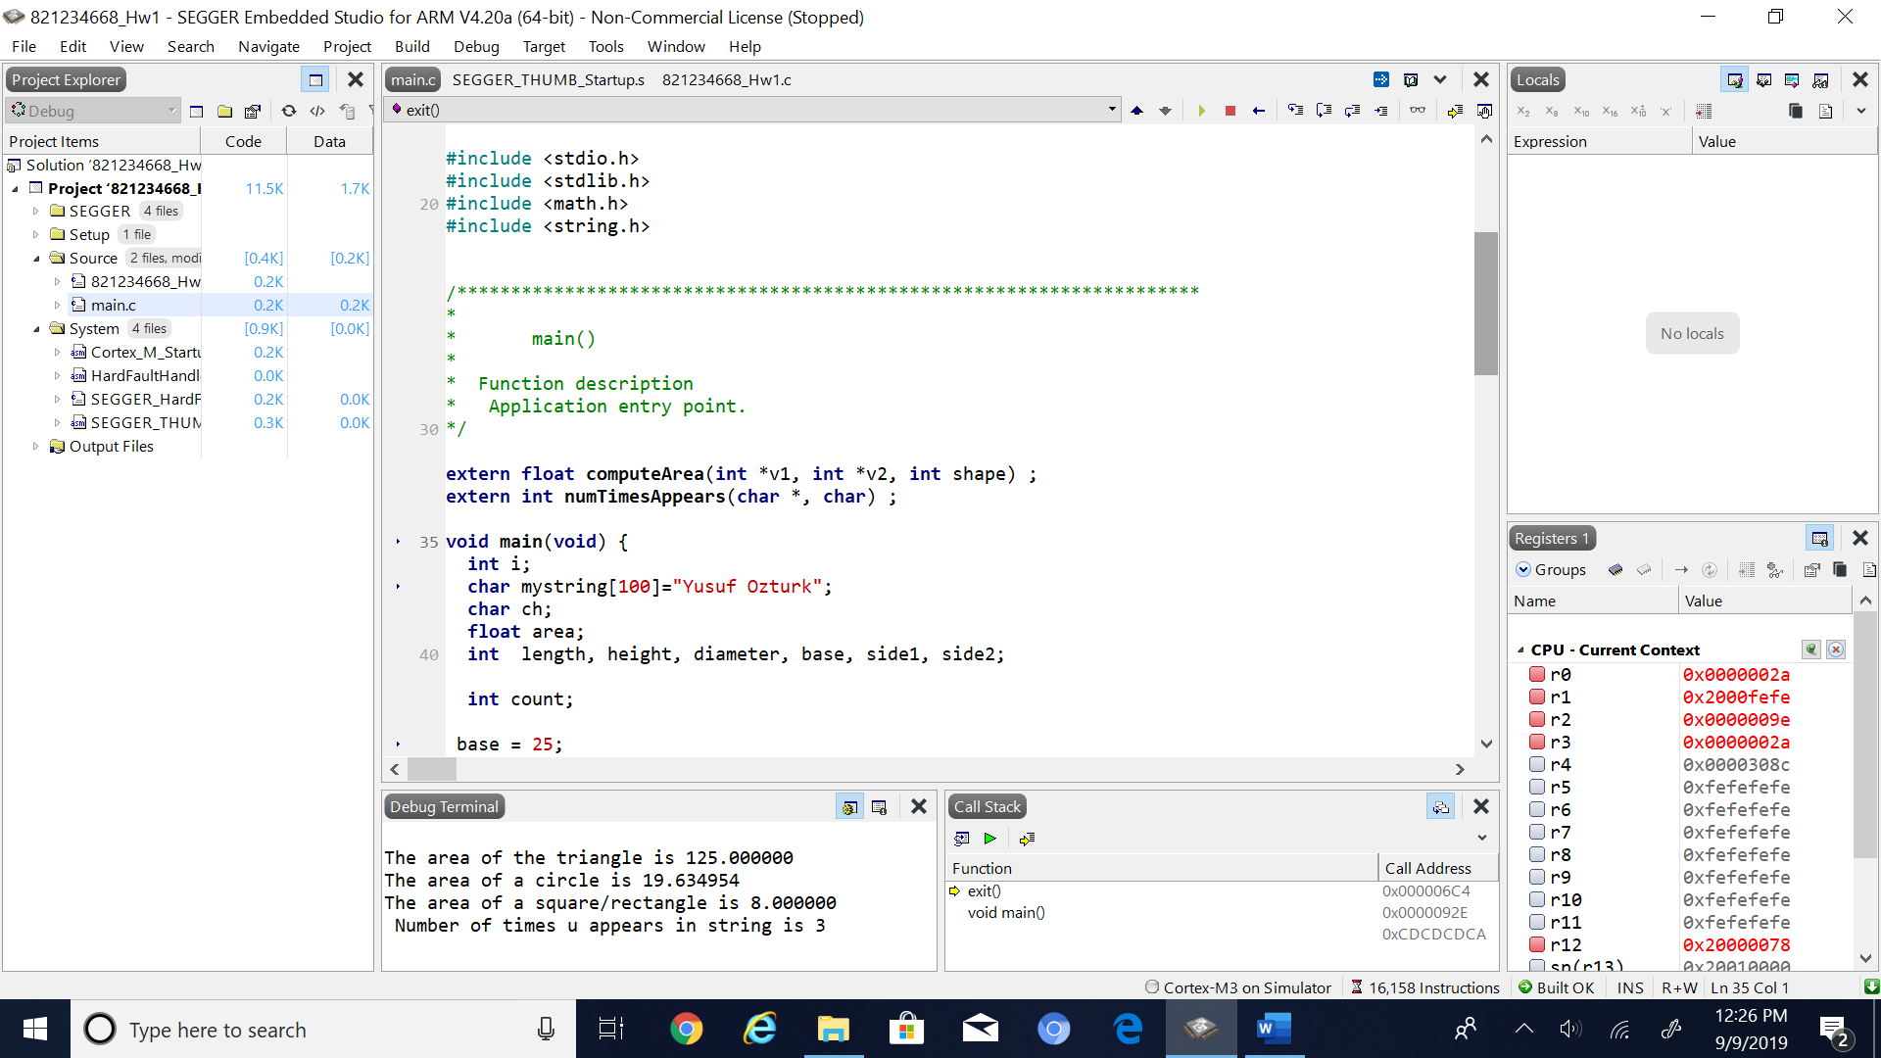

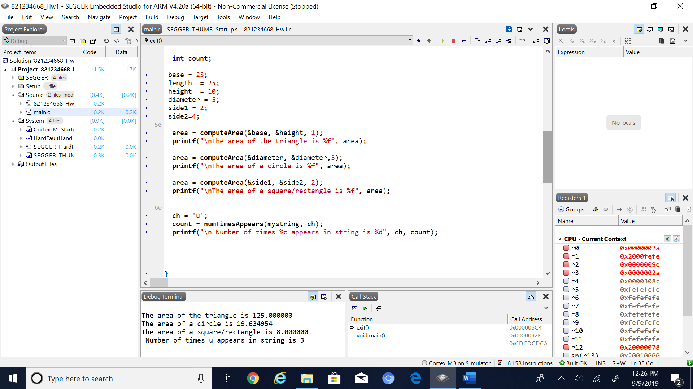

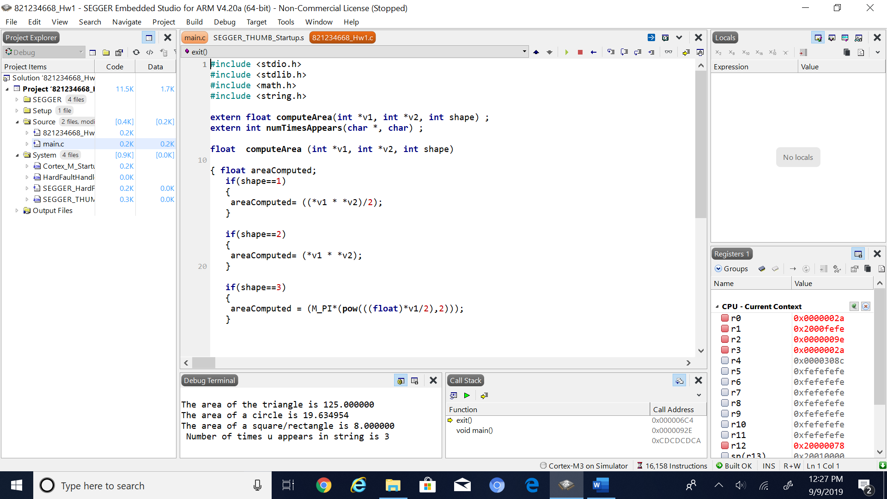

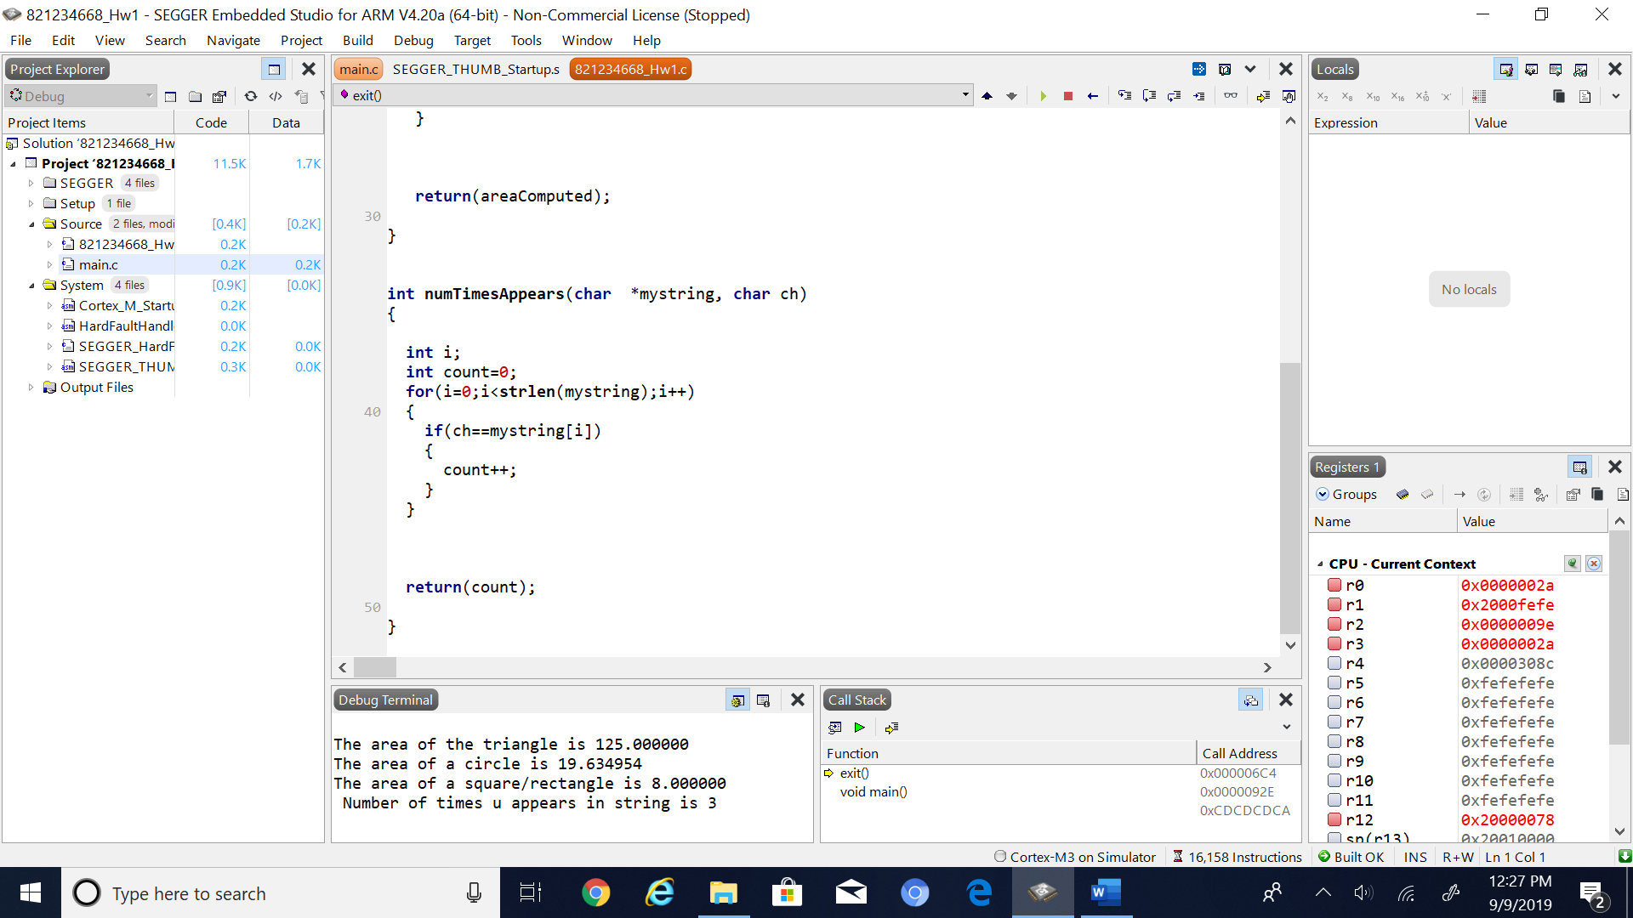

5. Conclusion (if applicable)

6*. References.

To complete this code I used slides that Professor Ken Arnold has provided on Blackboard to familiarize myself with c coding.